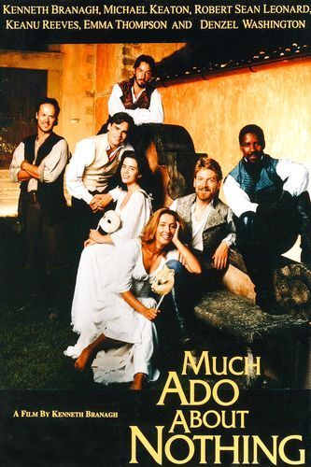

Directed by Mrs.Timm

Salman Kanian as
Dogberry
Salman kaniain as dog berry
Player-f

